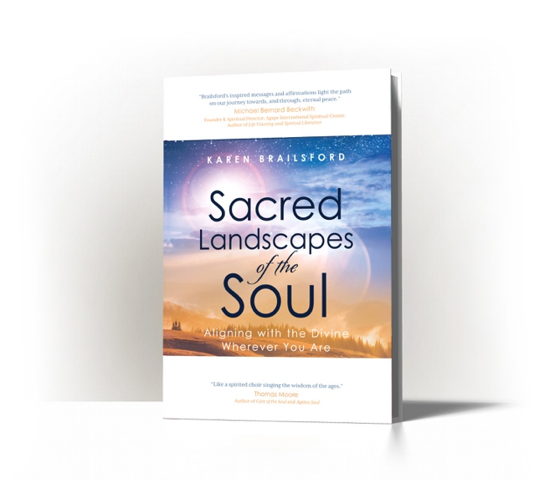

About Karen Brailsford

Author, spiritual guide and literary agent Karen Brailsford released her debut book Sacred Landscapes of the Soul: Aligning with the Divine Wherever You Are, published by Wyatt-MacKenzie, in 2020. Sacred Landscapes is the winner of a Gold Nautilus Book Award and a National Indie Excellence Award.
The paperback edition was published in April 2021.

A native New Yorker and Yale graduate, Karen is a licensed spiritual practitioner with the Agape International Spiritual Center in Los Angeles and the coordinator of its pastoral care ministry. She has worked on staff at Newsweek, Elle, People, In Touch and E! Entertainment covering arts and culture, Hollywood, fashion, beauty and human interest. The mother of actress Amandla Stenberg, Karen acted as her de facto manager for years, employing the expertise she gleaned from interviewing Hollywood celebrities, covering Fashion Week and negotiating with publicists.

Karen joined Aevitas (Uh-VEE-tis) Creative Management as a literary agent in 2020 where she represents books “that inspire and shine a light on contemporary conditions,” including a biography of Kamala Harris (Kamala’s Way, Simon & Schuster, 2021) and a forthcoming biography of George Floyd (His Name Is George Floyd, Viking, May 2022). In 2021 she was honored to present a talk and guided meditation for the Dalai Lama’s Global Vision Summit. You can read Karen’s essays, fiction, and poetry in Unity Magazine, the Write Volumes digital anthologies and on her blog, “A Life Is God Writ Large.”

Karen cites Paris as her favorite go-to landscape. Lately she’s been hanging out in the Garden landscape of the soul. Connect with Karen on karenbrailsford.com.

Instagram:@iamkarenbrailsford
Twitter: @iamkarenvb
Facebook: https://www.facebook.com/SpiritKnit

